Azure Cloud

**Aim**: - Create a virtual machine – Ubuntu server, Snapshot of Disk, Expansion of Disk and Manage Azure resources in the Azure portal.

# **Create a Linux Ubuntu Server virtual machine in the Azure portal**

Azure virtual machines (VMs) can be created through the Azure portal. This method provides a browser-based user interface to create VMs and their associated resources. To shows you how to use the Azure portal to deploy a virtual machine (VM) in Azure that runs Ubuntu server. To see your VM in action, you then create an SSH connection with the VM.

1. Sign in to Azure

2. [Create virtual machine](https://learn.microsoft.com/en-us/azure/virtual-machines/linux/quick-create-portal?tabs=ubuntu#create-virtual-machine)

3. [Connect to virtual machine](https://learn.microsoft.com/en-us/azure/virtual-machines/linux/quick-create-portal?tabs=ubuntu#connect-to-virtual-machine)

4. Create Snapshot of Disk and Expansion of Disk

5. Manage Azure resources

1. Sign in to Azure

Sign in to the Azure Portal and go to the Azure portal home page <https://portal.azure.com/#home>.

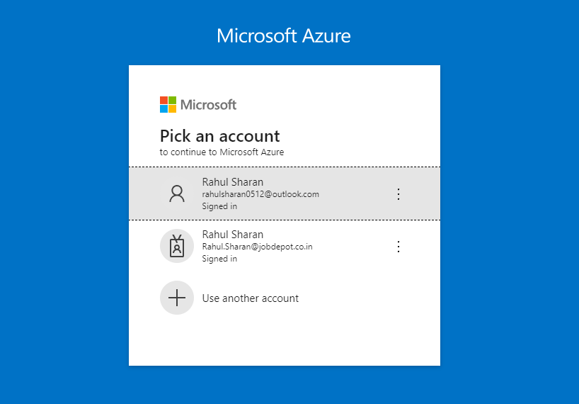

2. Create virtual machine

Create virtual machine - Ubuntu Server.

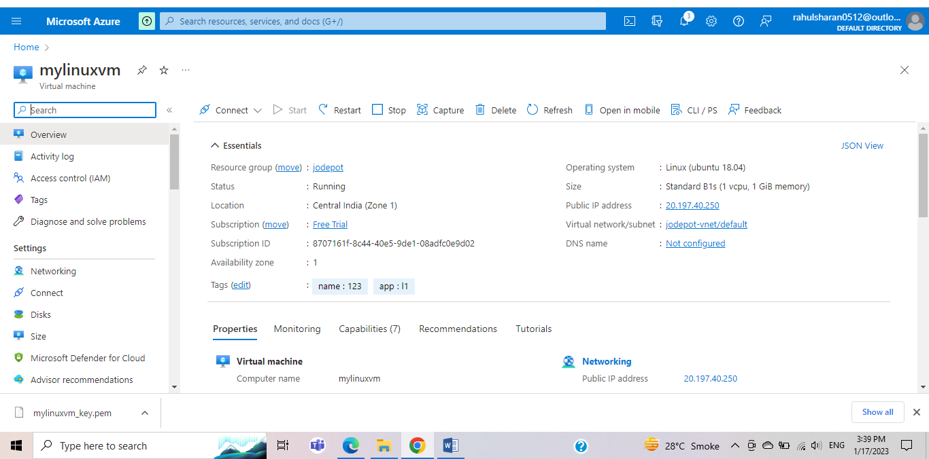

3. Connect to virtual machine

Connect using cloud shell via SSH with client.

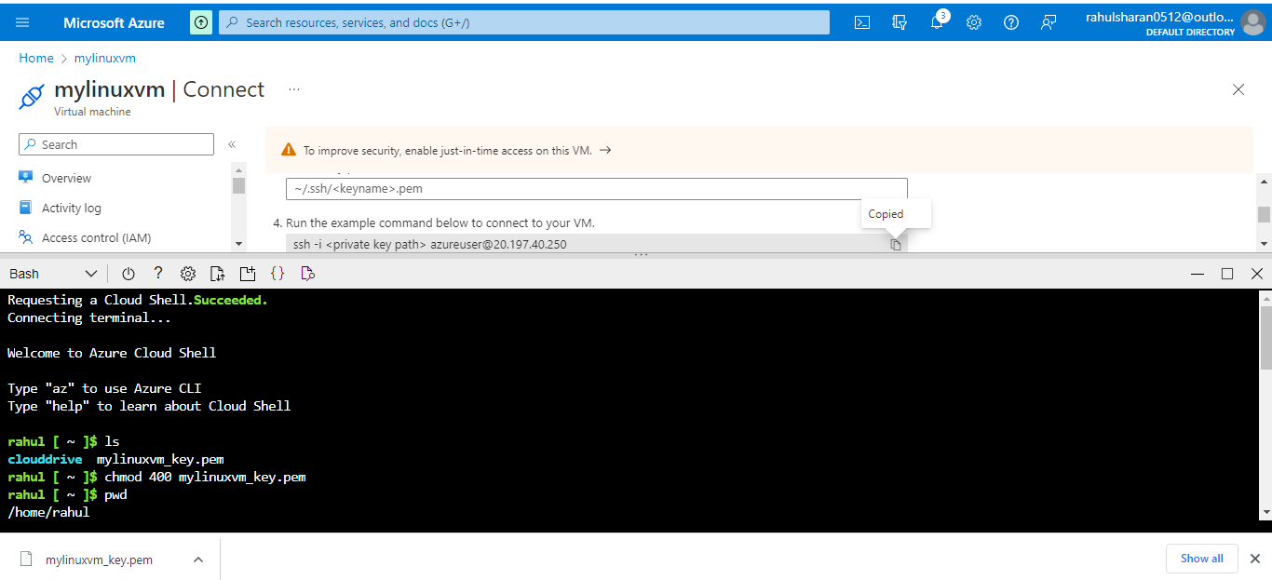

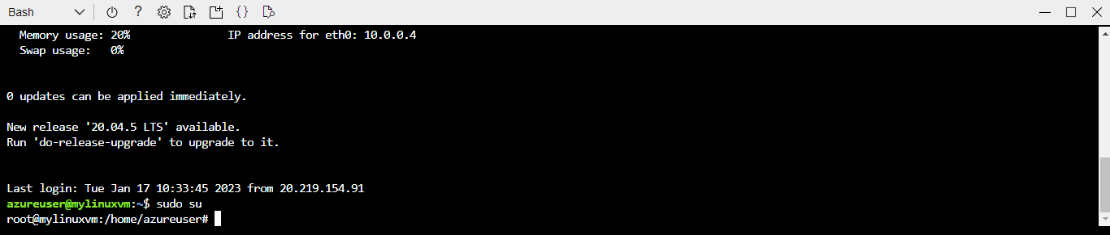

4. Create Snapshot of Disk and Expansion of Disk

1. Take Snapshot of Disk.

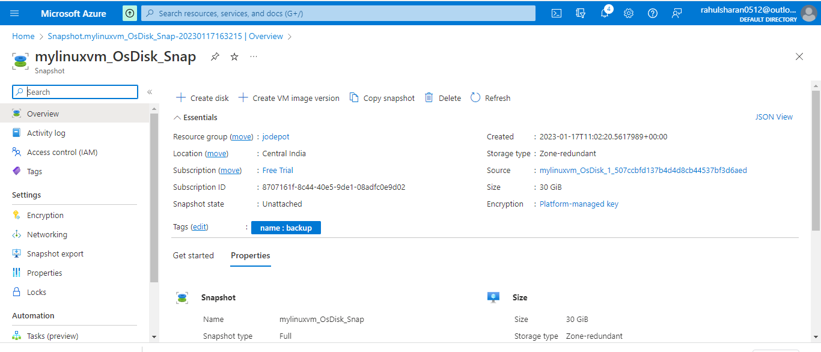

2. Scaling OS disk size.

Changes to the disk size can be made only when the disk is unattached or the managing virtual machine(s) are deallocated.

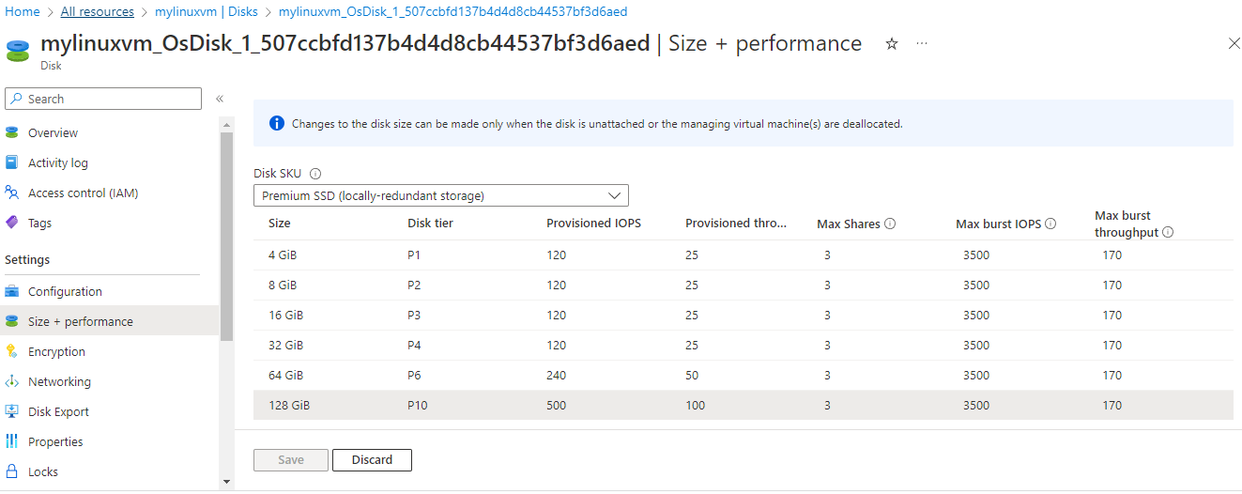

3. Stop VM.

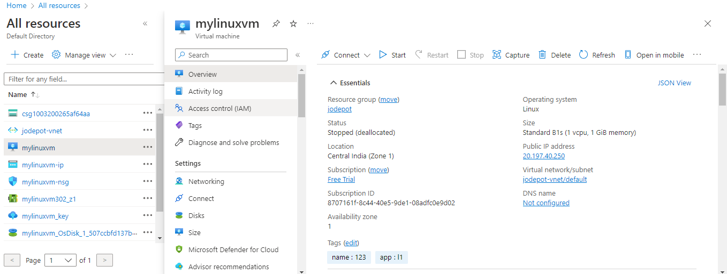

4. Extend disk to the required size

Select Size + Performance ->Select the size SKU ->Click on resize

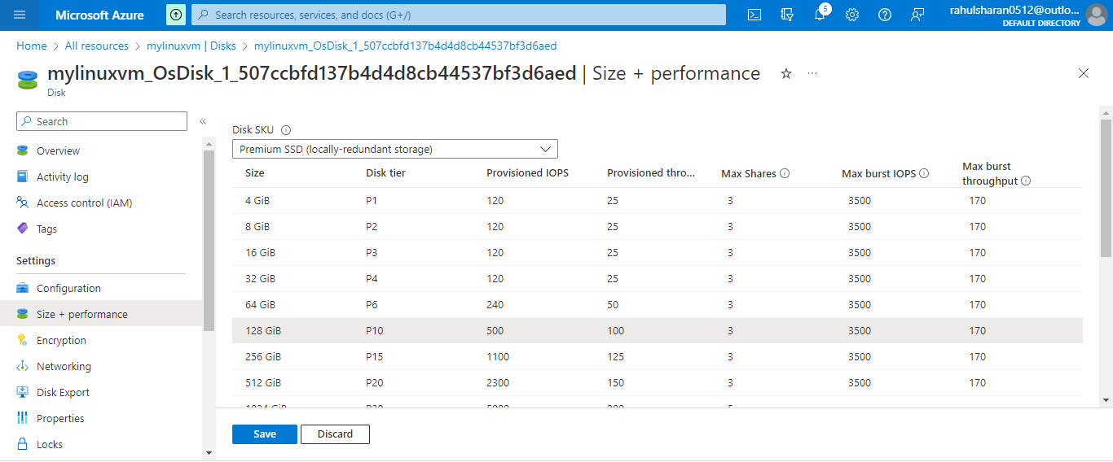

4. Once completed, will get below output.

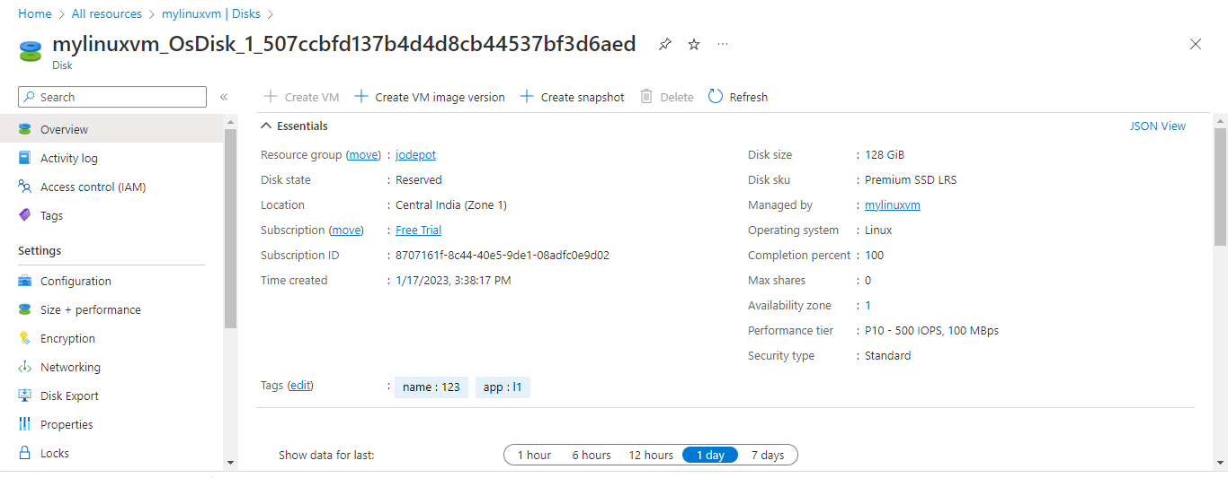

5. Start the VM and login to the VM once the disk size is updated then check the disk status.

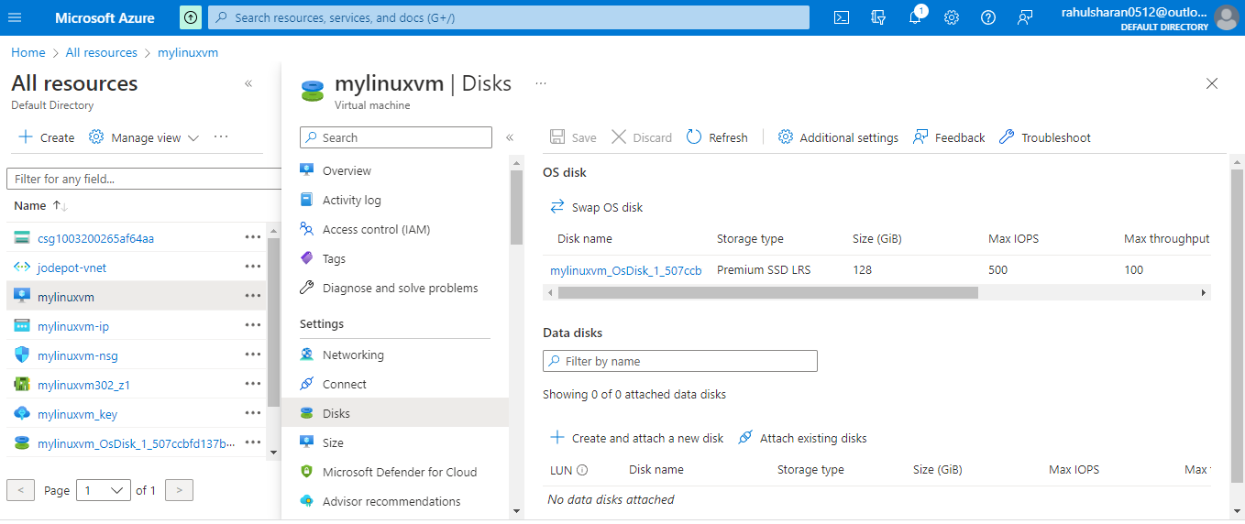

6. Scaling Data disk size in Windows and Linux.

Disks-> Create Disk->Save

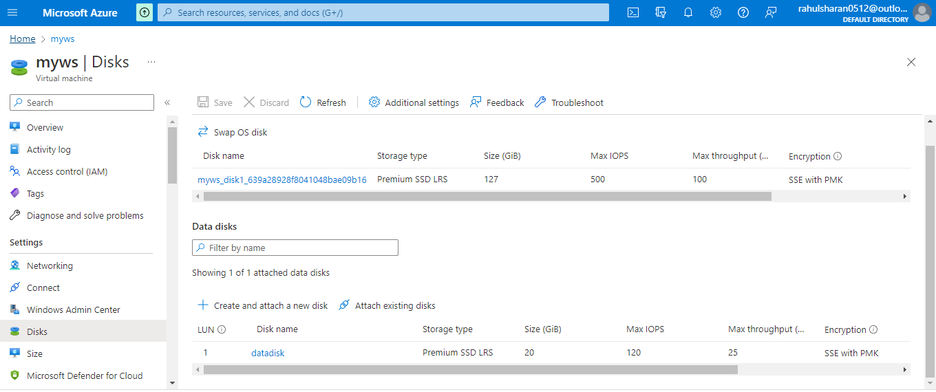

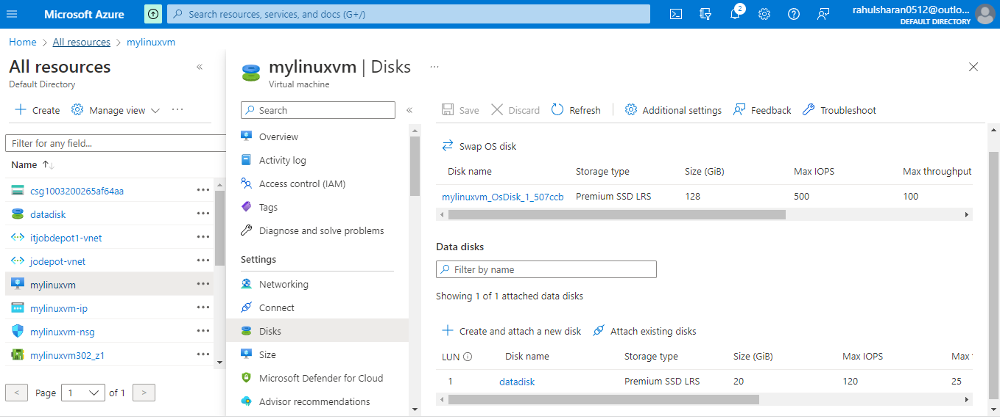

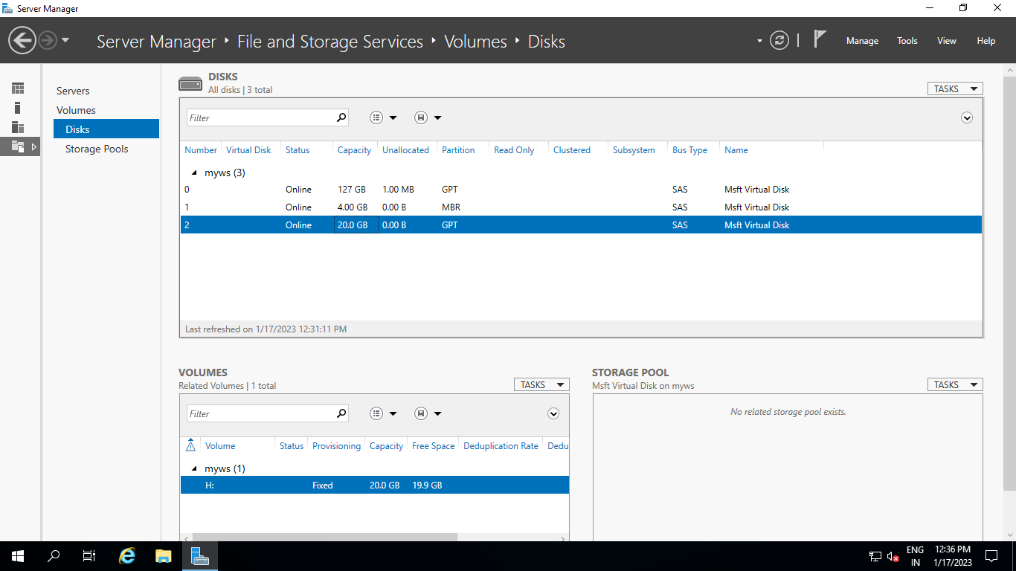

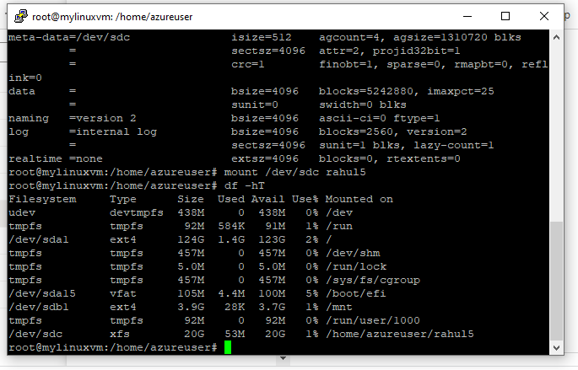

5. Manage Azure resources

To move resource groups.

Moving 'mylinuxvm' from resource group 'jodepot' in subscription 'Free Trial' to resource group 'itjobdepot1' in subscription 'Free Trial'

Resource group (move)->Source Target->Resource to move->review

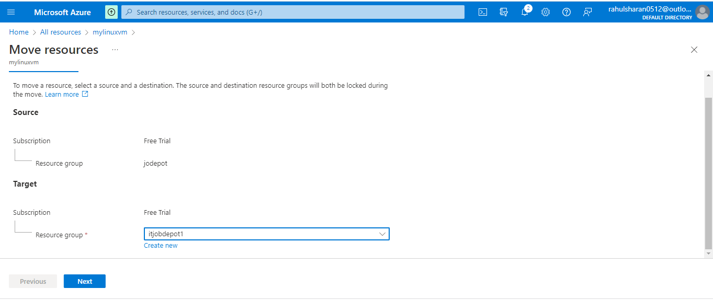

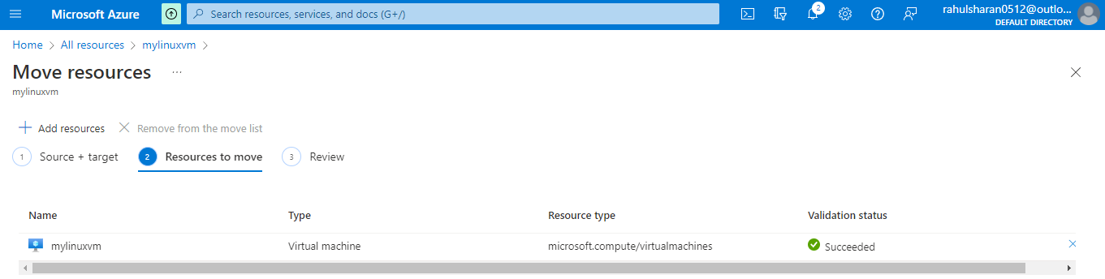

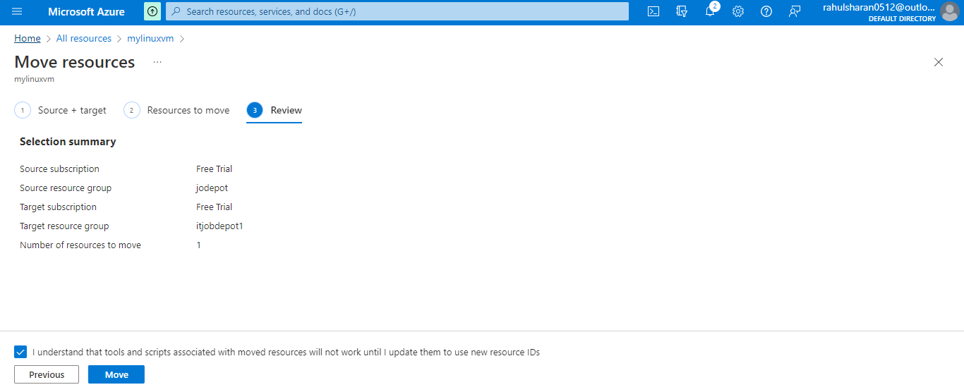

Successfully moved 'mylinuxvm' from resource group 'jodepot' in subscription 'Free Trial' to resource group 'itjobdepot1' in subscription 'Free Trial'

